Core Java Project Proposal

Hospital Management System

Presented By

**Najmul hassan somrat**

**ID :221-35-1081**

Email: somrat35-1081@diu.edu.bd

Presented To

**Akash Gosh**

Lecturer

Department of SWE

NOVEMBER 2023

**Introduction**

Title

Hospital Management System

Concept

Hospital management system can be designed with several key concepts

User login & check password mechanisms to ensure that only authorized personal can access the system. The other key add patient all records such as patient information, including personal details, all medical history etc. Delete all Records, display records, doctor management, Billing system, Reporting & Exit this system.

Features

Hospital Management System Mainly have Five parts This Project Using

1. Username & Password /login
2. Add patient
3. Display patient’s records
4. Delete patient
5. Exit/logout

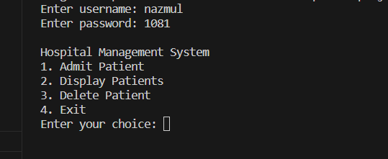

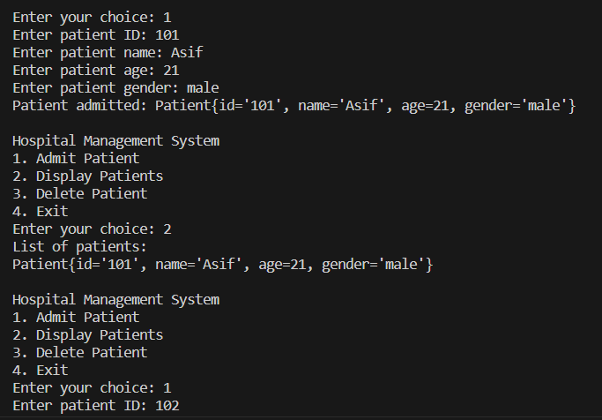

**Motivation**

First, I would like to thank my dear teachers for helping me in this project and for guiding me forward.

The motivation for a Hospital Management System project lies in improving healthcare administration, providing better patient care, and adapting to the evolving landscape of healthcare technology. The project aims to bring efficiency, accuracy, and enhanced decision-making to the complex world of hospital management.

Plan

Developing a Hospital Management System in Java involves a systematic approach to design, development, testing deployment, User Interface (UI), Security Implementation, User training, project Review. Plan for future enhancements and additional features, such as electronic health records (EHR), pharmacy management. This project plan provides a structured framework for developing a Hospital Management System in Java. Keep in mind that flexibility is essential, and adjustments may be needed as the project progresses.

**Resources**

Language

* Java Language

Tool

* IntelliJ IDEA Community
* Visual studio